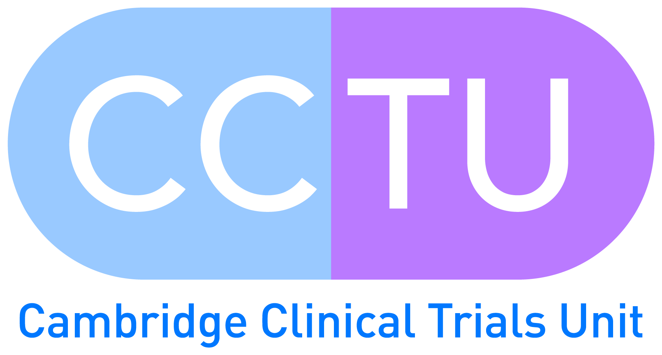

**Cambridge Clinical Trials Unit**

Coton House, Level 6 Box 401

Addenbrooke’s Hospital

Hills Road

Cambridge

CB2 0QQ

**Director:** Professor Ian Wilkinson

[ibw20@cam.ac.uk](mailto:ibw20@cam.ac.uk)

**Operations Director CCTU:** Louise Stockley

[Louise.stockley@addenbrookes.nhs.uk](mailto:Louise.stockley@addenbrookes.nhs.uk)

**General Enquiries:** 01223 596474

[cctu@addenbrookes.nhs.uk](mailto:cctu@addenbrookes.nhs.uk)